National University of Computer and Emerging Sciences

(Lahore campus)

Department of Computer Science

CS-401 Artificial Intelligence

Sessional II (Fall 2012)

Section B

Instructor:
Dr. Kashif Zafar

November 16, 2012

Total Marks: 100 Time Allowed: 90 minutes

- No marks for over writing or cutting
- Exam is closed book and notes
- Solve Q1 on the question paper and rest on the answer sheet provided.

Roll No: __________ Name: _________________ Section: ______

Question | 1 | 2 | 3 | 4 | 5 | Total
Points | 30 | 15 | 20 | 15 | 20 | 100
Score

Q1. Multiple Choice Questions [30 marks]
Note: No mark will be awarded for cutting or marking more than one option. Each MCQ carries 2 marks and (T/F) is of 1 mark each.

- (Minimax search) At minimizing nodes, we stop evaluating children if we get a child whose value is ------------- the current lower bound (alpha).
- Equal to
- Less than
- Greater than
- Not equal to

- Iterative deepening can also be used with ------------- algorithm.
- Depth first search
- Breadth first search
- Hill climbing search
- A* search

- A search algorithm is ------------if, for any graph, it always terminates in the optimal solution path whenever a path from the start to a goal state exists.

- Monotonic
- Informed
- Admissible
- None of the above

- When a state is discovered by using heuristic search, is there any guarantee that the same state won’t be found later in the search at a cheaper cost is the property of -----------------.
- Optimality
- Monotonicity
- Reflexivity
- None of the above

- The procedural knowledge is contained in a control structure called -------------

- Inference engine
- Recognize-act cycle
- Knowledge base
- Explanation sub-system
- None of the above
- Once a rule has fired, it will not fire again until the working memory elements that match its conditions have been modified is called -------------.

- Specificity
- Recency
- Refraction
- Admissibility

- Forming high-level conclusions from collection of raw data is called-----------------

- Planning
- Interpretation
- Planning
- Diagnosis

- A stronger form of learning occurs if we increase the weights, if both the neurons are “off” at the same time. This type of training version is referred as --------------

- Delta rule
- Hebb rule
- Gradient descent learning rule
- Perceptron rule

- The perceptron learning rule is a more powerful learning rule than the----------.

- Delta rule
- Hebb rule
- Gradient descent learning rule
- Perceptron rule

- WEKA tool uses ------------ file for importing data for analysis.
- .doc
- .xls
- .wka
- .arff

Write True (T) or False (F) for the questions below: (10)

- In back-propagation algorithm, each weight configuration can be represented by a point on an error surface. ( T )
- Perceptron rule attempts to minimize the local error and uses the derivative of the error to find the slope of the error space in the region local to a particular point. ( F )
- The activation function must be differentiable (i.e. continuous) for gradient descent learning approach. ( T )
- In Genetic Algorithm, learning is viewed as a competition among a population of evolving candidate problem solutions. ( T )
- Mutation can unite an individual that is doing well in one dimension with another individual that is doing well in the other dimension. ( F )
- Crossover is important in that the initial population may exclude an essential component of a solution. ( F )
- In binary coded chromosomes, every gene has two alleles. ( T )
- If the population size is too large, the processing time is low and the GA tends to take longer to converge upon a solution. ( F )
- The value of each gene of an offspring’s chromosome is randomly taken from either parent is called one-point crossover. ( F )
- Mutation is used to make small random changes to a chromosome in an effort to add diversity to the population. ( T )

Section II

Q2. (a) How you represent characters O and X for 5 * 5 matrix in ANN? What activation functions can be used for representation (4)

(b) Show the mathematical working of Artificial Neural Network by taking the case in figure below. First two columns are the input values for X1 and X2 and the third column is the desired output. Show only 3 iterations (4)

0 | 0 | 0
0 | 1 | 1
1 | 0 | 0
1 | 1 | 1

Learning rate = 0.2
Threshold = 0.5
Actual output = W1X1+W2X2
Next weight adjustment = Wn+ΔWn
Change in weight = ΔWn = learning rate * (desired output- actual output) * Xn

Show two complete iterations for acquiring the desired output?

x1 | x2 | w1 | w2 | D | y | Δw1 | Δw2

Q3. (a) A Robot is in cell A, wants to go to cell I, with given constraints (order of movement is up, down, right, left and blocks B, C and H are blocked (robot can’t go to these blocks). Draw the path (tree) for the robot using: (10)

- A* search
A | B | C
D | E | F
G | H | I
- Genetic algorithm

Q4. (a) Draw architecture of a typical rule based expert system and label all parts. (5)

b. Genetic Algorithm for classification:

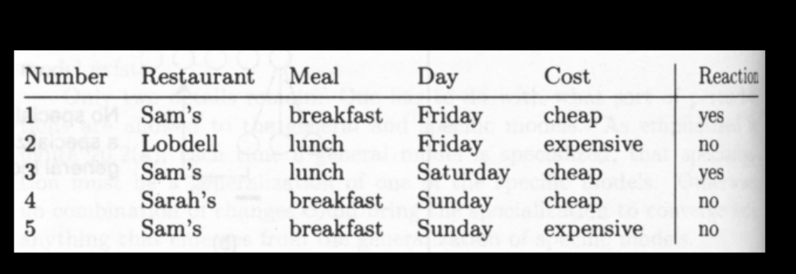

Suppose we have the supervised data and a chromosome representing a rule:

Sam | breakfast | X | X

IF Restaurant = Sam, and Meal = breakfast, and Day = X, and Cost = X
THEN
Reaction = Yes
ELSE
Reaction = No
(where X is a general, don’t care value which matches every value)
What would be the fitness of the chromosome, if the fitness function is the
number of data samples which are correctly classified by the chromosome. (5)

Q5. (a) A generation has 20 chromosomes, out of which 3 fittest ones are placed in the next generation without any competition from the offspring. The rest of the 17 chromosomes of the next generation are chosen from the pool of parents and offspring. Suppose 12 chromosomes of the offspring make it to the new generation. What is the generation gap and elitism. Duplicates are not allowed. (3+3)

(b) Suppose there are 10 chromosomes with fitness as shown in table. What will be
the selection probability according to proportionate and linear rank selection
method. (10)

Chromosome No. |  |  | Fitness
 | A | 50
 | B | 25
 | C | 25
 | D | 100
 | E | 75
 | F | 125
 | G | 250
 | H | 110
 | I | 140
 | J | 100
Q6. 



